He asked the man any number of questions about his son. I really like the idea that Jesus, Who has the omniscience of God, created a dialog with the people. It means He is willing to talk with me. I also like the words of verse 23, "If you can!", I hear Jesus acting incredulous for the sake of the man's faith. Sin keeps us from asking God for the things we sincerely need. God is ready to supply our lives we are too afraid to ask. We need to cry out, with the man, "help my unbelief," cry out to God to fill us with a vibrant and living, fearless faith, so that we receive the gifts of God in awe and wonder.

PRAYER OF THE CHURCH
℗ O God, Father Almighty, in the mystery of Your Eternal Love, You ordained Your Son to be the sacrifice for our sin. You laid on Him the punishment for our sin, and gave us the gift of His death which has become for us life through faith in Him.
Through the fruit of The Tree of The Knowledge of Good and Evil and the disobedience of Adam and Eve we were cast into the pit of hopelessness and despair. Through the Fruit of the tree of the cross, the obedience of Your Son our Savior, we have been taken out of the pit and set into Your eternal kingdom. For this we are grateful in measure beyond words.
O Lord, we are tempted to think that our good works deserve Your attention, or we have permitted Satan to make us feel that our past sins are so great that You won't listen to us. For our thoughts of self-righteousness and self-condemnation, forgive us.
Grant us a lively faith in Jesus, that we may understand both the infallible proofs of His death and the infallible testimonies of His Resurrection. As You have declared that if we confess with our mouth the Lord Jesus and believe in our heart that You raised Him from the dead, we shall be saved, fill us with a full measure of Your Holy Spirit that we are able to accomplish what You ordained.
Help us follow Your Son Jesus Christ more closely. Help us deny ourselves to take up our cross. Give us the courage to make sacrifices that Your Gospel might reach people both near and far. Give us insight to understand that as we lose our life in service to You and others, we will find it.
For all among us who have trouble, care, or sorrow, we ask that You would quicken them in the knowledge and work of Your Sovereign authority.
Hear us as we bring to You our private petitions. (Time of silent prayer.)
All this we pray by the blessings and benefits we have obtained through Jesus Christ our Lord and Savior.
© Amen.
PROPER NINETEEN

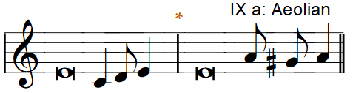
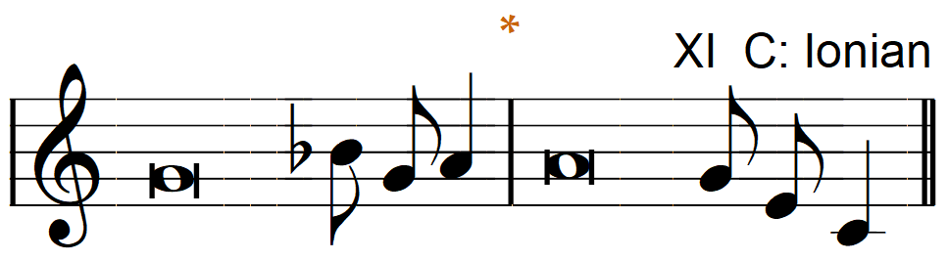
Chant Tone
Introit  Be strong, and let your heart take  —courage,*  all you who wait|for the Lord!  But I trust in You,—O Lord,*  I say, "You|are my God."  My times are|in Your hand;*  rescue me from the hand of my enemies and from my perse—cutors! | Make Your face shine on Your—servant;*  save me in Your|steadfast love!  Glory be to the Father and|to the Son*  and to the Holy—Spirit;  as it was in the be—ginning,*  is now, and will be forever.—Amen.  Be strong, and let your heart take  —courage,*  all you who wait|for the Lord!  (Antiphon, Psalm 31:24;  Psalm 31: 14-16)

Collect of the Day
Lord Jesus Christ, our support and defense in every need, continue to preserve Your Church in safety, govern her by Your goodness, and bless her with Your peace; for You live and reign with the Father and the Holy Spirit, One God, now and forever.

Gradual
Fear the Lord,|you His saints,*
for those who fear Him lack—nothing!
Many are the afflictions of the—righteous,*
but the Lord delivers him out|of them all.

(Psalm 34:9, 19, alternative)

Scripture quotations are from the Holy Bible, English Standard Version® ESV© Copyright© 2000; 2001 by Crossway Bibles, A Division of Good News Publishers, used by permission. All Rights Reserved.
ENTRANCE PRAYER: With all that is within us, O Lord, we bless Your Holy name. You forgive all our iniquities and heal our diseases. You redeem our life from destruction and crown us with loving kindness and tender mercies. For all these blessings, O Lord, we give You thanks. By Your Spirit help us reflect Your mercy toward others. Make us confident that You will take our mistakes and turn them into blessings. Be with the lonely, comfort the sick and bring the assurance of Your forgiveness to the penitent. This we ask in the name and for the sake of He who brought us to Himself, even Jesus Christ our Lord and Savior. Amen (So be it, Lord.)

ACCORDING TO THE WALL STREET JOURNAL, THE NUMBER OF CHRISTIANS KILLED, BEATEN, RAPED OR OTHERWISE MOLESTED IS ON THE RISE. A group out of Toronto, Ontario, FFN, tracks the numbers and they are staggering. It is officially illegal to convert to Christianity in Iran. Egypt (where toleration of religion is practiced,) has the highest incidence of terrorism against their government by Muslim extremists. It takes a great deal of courage to be a Christian in a Muslim country. It takes a secure belief in Jesus to proclaim Him as Lord and Savior in any country. The Apostles gave up everything to follow Jesus. They understood that He is the Christ, and we really have no choice but to give up our life in deference to His sovereign nature.

THEME OF THE DAY
The Boundaries of Faith
INTROIT—(Antiphon: Psalm 31:24;) Psalm 31:14-16
Psalm 31 was written by David while being pursued by Saul. He relates the narrow escape he had at Keilah and in the wilderness of Maon. The Psalm is a mixture of prayer and praise for having been preserved by God David recognized that because of his sin there had been no reason for God to keep him safe.

COLLECT
This Collect, written for the latest revision, reflects the general Collects of the non-festival half of the church year. We ask that Jesus would preserve and defend the Church from the attacks we endure.

OLD TESTAMENT LESSON—Isaiah 50:4-10
The Servant is prepared by God to be a prophetic voice to the weary and to suffer all manner of mockery and disgrace, trusting that God alone will be His help and vindication. In this text the sinful children are being pleaded with to remain open to God, and not close their ears. They are to be like the Servant. We are to be on guard against sin, especially against envying the prosperity of the wicked. We are prone to learn things the hard way. There is cause for celebration even in the hard way, because the Servant, our Brother Jesus passed through this life in the hardest of way, and now He ensures that we are able to follow by trusting in Him.

GRADUAL—Psalm 34:9, 19 alternative
We use Psalm 34:9 and 19 to remind ourselves of fearless faith which comes to us in the power of Jesus. Jesus came into the world to make satisfaction for our sin. Our afflictions of being sinned against come from Satan, the world and our own sinful flesh. Yet we are delivered and freed from sin, to forgive and free others.

EPISTLE LESSON—James 3:1-12
Our Introit, Epistle and Gospel lessons are all new to today. We have added in an entire day, to discuss our sinfulness and God's grace toward our prayer. Our Epistle Lesson continues the admonition from two weeks ago, that what comes out of us shows who we worship. Our sin often controls our tongue. We say hurtful things, rather than speaking the truth in love, and proclaiming the blessing of God. Employ your tongue for righteous prayer. In that way your mouth will be tamed and not a "restless evil, full of deadly poison."

GOSPEL LESSON—Mark 9:14-29
Jesus certainly spent a lot of time asking questions in our Gospel Lesson for today. He asked the Disciples what they were debating with the scribes,

